FUNCTION AND PERFORMANCE TESTING

MODEL PERFORMANCE TEST

|  |  |
| --- | --- |
| Date | JUNE 2025 |
| Team ID | LTVIP2025TMID50867 |
| Project Name | ToyCraft tales: tableau's vision into toy manufacturer data |
| Maximum Marks |  |

Model performance Testing:

|  |  |  |
| --- | --- | --- |
| S.NO | Parameter | Screenshot/values |
| 1. | Data Rendered | Shown below |
| 2. | Data Preprocessing | Shown below |
| 3. | Utilization of Filters | Shown below |
| 4. | Calculation fields Used | Shown below |
| 5. | Dashboard design | No of Visualizations / Graphs |
| 6. | Story Design | No of Visualizations / Graphs |

Data Rendered

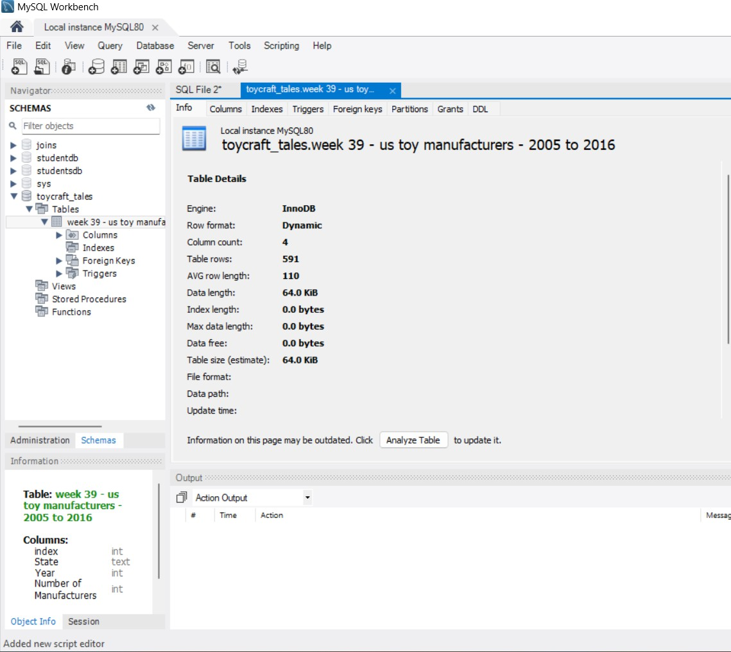

Utilization of filters

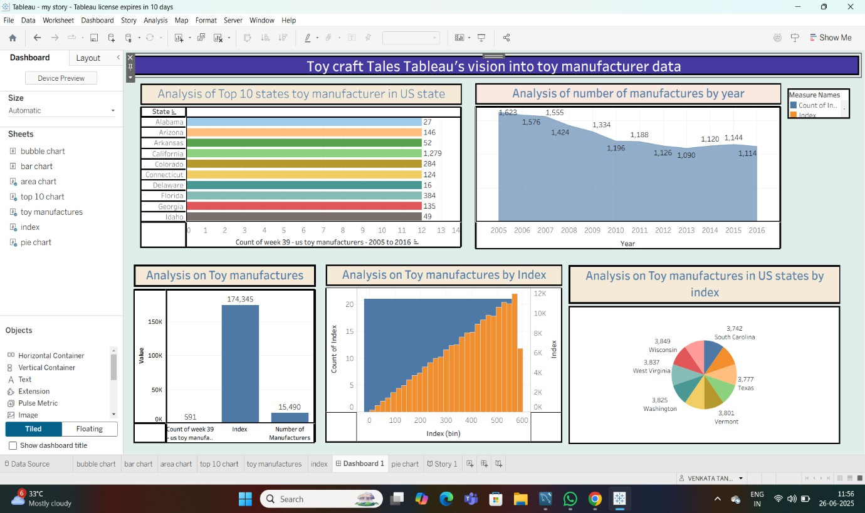

Calculation fields Used

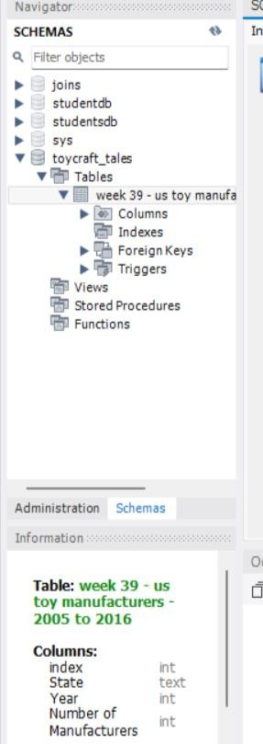

Dashboard design



1. Analysis of the number of Manufacturers by Year
2. Analysis of Toy Manufacturer by Index
3. Analysis of toy Manufacturers in US state By Index
4. Analysis of Toy Manufacturers
5. Top 10 states toy manufacturer in US state

Story design

